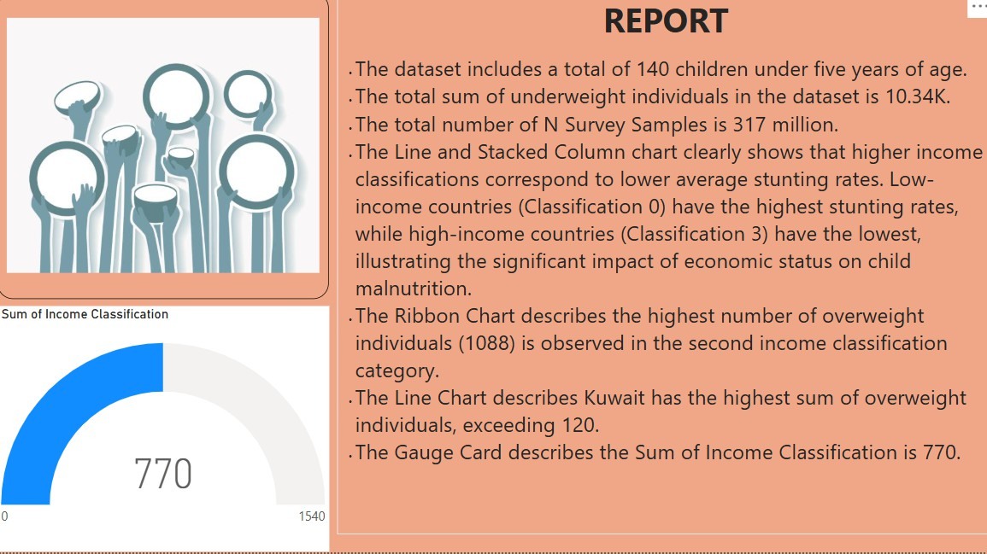Report

|  |  |
| --- | --- |
| Date | 20 June 2024 |
| Project Title | Global Malnutrition Trends: A Power BI Analysis (1983-2019) |
| Maximum Marks | 5 Marks |

# A Report on Global Malnutrition Trends (1G83–201G)

A report is a comprehensive document that provides a structured and detailed overview of the data analyzed to extract meaningful insights. Such reports aid in understanding patterns, disparities, and trends across regions and categories related to malnutrition indicators. Reports are essential for policymakers, healthcare organizations, and global agencies to design interventions aimed at reducing malnutrition globally.

Designing a report in Power BI includes connecting to large datasets, visualizing key performance indicators (KPIs) such as population counts, survey coverage, and malnutrition measures (underweight, stunting, overweight), and presenting them through

various visuals like bar charts, line charts, ribbon charts, and gauge cards. The placement and clarity of these visuals ensure easy interpretation by both technical and non-technical stakeholders. Iterative design and feedback incorporation ensure that the report remains relevant and actionable.

# Observations drawn from the Power BI report:

## Under-Five Population Analysis:

The dataset covers a total of **140 under-five children**, offering insight into the sampled population relevant to global malnutrition trends.

## Survey Sample Size:

The survey involves a massive sample of **317 million individuals**, enhancing the credibility and generalizability of the analysis across multiple countries and income groups.

## Underweight Individuals:

The total number of underweight individuals recorded in the dataset is **10.34K**, emphasizing the burden of undernutrition within the studied population.

## Income Classification s Stunting:

The **Line and Stacked Column chart** highlights that **low-income countries (Classification 0)** suffer from the highest stunting rates, whereas **high-income countries (Classification 3)** report the lowest. This indicates a strong inverse relationship between economic status and child stunting prevalence.

## Overweight Individuals by Income Class:

The **Ribbon Chart** reveals that the second income classification group registers the **highest overweight count of 1,088 individuals**, suggesting that economic transition phases might influence dietary patterns and nutritional outcomes.

## Country-Wise Overweight Distribution:

From the **Line Chart**, **Kuwait emerges as the country with the highest sum of overweight individuals, exceeding 120 cases**, pointing towards a possible regional or cultural impact on nutrition.

## Gauge Card Insight:

The **Gauge Card** shows that the **Sum of Income Classification equals 770**, providing a quick reference value related to income classification measures used in the analysis.

# Sample Insights for Decision-Making:

## Nutritional Dual Burden:

Both **undernutrition and overnutrition coexist** in different income groups, highlighting the need for **diversified nutrition policies** tailored to economic conditions.

## Target Regions:

**Low-income countries require focused interventions** to reduce stunting, while middle-income regions may need to address rising overweight prevalence.

## Country-Specific Strategies:

Kuwait and similar nations might benefit from public health initiatives to tackle rising obesity levels among children.